英语记叙文写作

一、 记叙文的特点

记叙文是以叙述、描写为主要表达手段来记人、叙事、写景、状物的一种文体。

通常分为三类：

1．以人物为主的记叙文，即以人物为中心组织材料，围绕这个人物来写一件或两件事。考查的方式主要是介绍一个自己喜欢的或者熟悉的人或者偶像，或者写一个人物传记等等。

2．以事件为主的记叙文，即以事件为中心组织材料，围绕中心事件，可以写一个人或几个人。考查的方式主要是日记，新闻报道，或者和写信与他人交流，记一件难忘的，开心的事或者一个活动。

3．以写景状物为主的记叙文。但是“人以事显，事由人生”，人和事是密不可分的。也就是说，在一篇记叙文中，记人、写景、叙事往往是交织在一起的，不可硬性分开，但各有侧重。考查的方式主要是游记。

二、记叙文的写作技巧

在写记叙文时通常应遵循以下几点：

1．确定文章内容和中心。定内容时，选材要注意新颖和真实。因为新颖的题材才能吸引读者的兴趣，真实的内容才能流露出真情实感。选材时不一定总是要写惊天动地的大事，也可以写日常生活中的小事，通过“以小见大”的点滴小事更能反映出一个人的性格特征和精神风貌，更能打动读者。定中心时要注意文章中心思想的明确和集中。要抓住文章要表现的精神，让读者一目了然。而且文章主旨要集中，不能太分散。

2．要交待要素，即时间、地点、人物、事件的起因、经过和结果。在行文的过程中交待要素时，不能呆板，要根据情况灵活把握。

3. 记叙文一定要有清楚的线索。虽然观察的角度、记述的方式可以不同，但每一篇文章都应当有一条关联材料、统贯全篇的中心线索，否则文章就会松散。

4．要力求内容具体。有了具体的内容，文章才能显得生动，才能使人受到感染并留下深刻的印象。要做到这一点，必须善于在叙事过程中对最能体现人物思想、性格特征的肖像、语言、行动和心理等进行适当地描写。

5．记叙文通常是按照事情发展的先后顺序来表达内容的，可以顺叙，也可以倒叙，而且要根据文章的中心确定详略并且要得当。

6．对于写景状物类的文章，要注意写出被描写事物的形和神，做到形神兼俱，更重要的是一定要写出作者的思想感情，表达出作者的人生态度和追求等。这类文章我们可以采用“借景抒情”“托物言志”的写作方法。

7．写作时要注意时态和人称。一般用第一人称写本人的经历和耳闻目睹的事情，用第三人称写他人经历的事情，记叙文所记的一般是过去发生的事情，所以原则上通常用过去时态来写。

**专题01. 故事类—记一件…的事**

【话题导入】

日常生活中，我们可以记录一些有趣或者有意义的事情，或难忘或遗憾，既可以把它们当作一种记忆的收藏，也可以与朋友一起分享。

【写作指导】

以写事为主的记叙文可以按照事件发展的顺序进行叙事，也可以倒叙，或者空间顺序进行记叙，要求考生从人物时间地点事情的起因经过及结果等方面进行，要保证叙事的相对完整性，内容全面，重点突出，详略得当，层次分明；要注意叙议结合，具体的介绍有时也要求考生表达自己的感受和收获，近几年高考的命题有了一种新的变化，即要求考生在记叙的基础上添加议论的成分，备考中要格外注意。通常是日记或者写信分享，写作的要求可以是要点提示类，也可以采用图画形式。写作的人称，通常为第一人称或第三人称，时态都用一般过去时。

* 写作步骤

1. Leading in
2. Process
3. The end.

* 增色语料

故事导入：attend, take part in, participate in, activity, celebrate, festival, pay a visit to, invite, spend… together

过程：set out, set off, arrive, start, hand out, gift, prepare for, help with, amazing, at first, gradually, performance, have fun, unforgettable, afterwards, party, hold, as well as, besides, happily, excited, agree, leave, return.

结局或感受：realize, be supposed to, care about, make joint efforts, abundant, culture, treasure, have a great time, make a difference

精彩句型:

1. One day/the other day/ a couple of days ago/ while I was… I…
2. It was snowing/raining heavily/ pretty hot on Monday morning…
3. Seeing this, I ran quickly over to him as soon as possible.
4. Without hesitation, I decided to give him a hand.
5. It turned out that…
6. I invited Tom, an exchange student studying in my school, to celebrate the Mid-Autumn Festival with my family yesterday.
7. I took part in the activity held by… to visit the elderly in the nursing home yesterday.
8. When he arrived, he was showed around, and then he was taught how to make moon cakes by my mother, which made him excited.
9. At first, he didn’t know how to make moon cakes and what he made made all of us burst into laughter.
10. Gradually he was able to make some good ones, and he said it was the first time that he had celebrated Mid-Autumn Festival in China.
11. The following day, we visited a lot of attractions in London.
12. It was amazing to learn how to make moon cakes, and we all agreed that the moon cakes made by ourselves were more delicious than those bought in the supermarket.
13. Tired as we were, we were very delighted because we made contributions to environmental protection
14. I never forget the day when we visited…
15. We spend about three hours there and then we returned to school by bus.

* 范文赏析

假设你是李华，作为你校志愿者协会的成员，去年你参加了你市举办的中秋节，看望敬老院老人的活动，请根据图片提示，用英语写一篇短文，并向校英文报投稿.

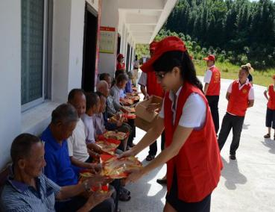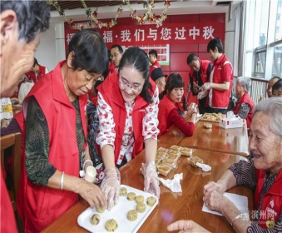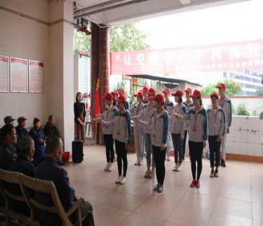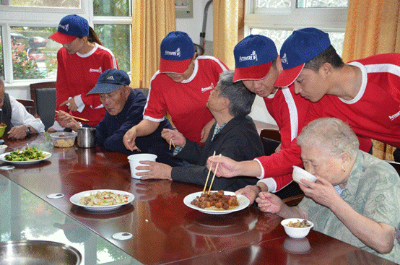

注意:1. 词数100字左右；2. 可以适当增加情节，使行文连贯。

**任务分析：**本篇是一篇记叙文作文主要介绍参加去敬老院看望老人的活动过程，需要包括记叙文的六大要素，时间地点，人物事情的起因经过和结果。

**补句成文：** 请根据汉语提示使用恰当的单词、短语或句子补全下面范文中所缺的内容，补全后请通读全文并建议记诵。

Last Mid-Autumn Festival, all the members of School Voluntary Association, including me, paid a visit to the elderly in the nursing home of our city.

When we arrived, first，_____________________________(我们把准备好的礼物分给老人). Then, we were taught how to make moon cakes. Some of us made a very good moon cakes，__________________________(这得到了老人们的高度赞扬). After that, we performed for them. In addition, we also invited some of them to perform with us together. ___________________________(老人们都认为这是他们度过的最有意义的中秋节). Finally, we enjoyed a big dinner together, after which we returned to school，

A little tired as we were, we were very delighted because we made contributions to delight the days of the senior people. I think the whole society should care more about elderly.

答案：1.we handed out the gifts we had bought to the elderly.

2.which was highly praised by the elderly. 3. The elderly all agreed it was the most meaningful Mid-Autumn Festival they had never spent.

【且学且练】

假定你是红星中学高三学生李华， 你班上周组织了一次以“劳动最光荣”为主题的社会实践活动。请根据以下四幅图的先后顺序，写一篇英文周记，记述整个过程。

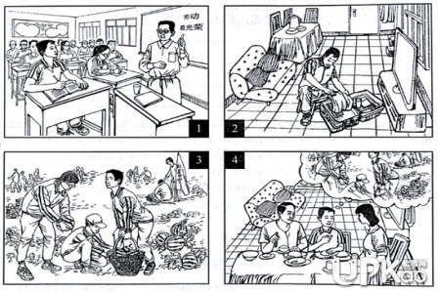

Last week I took part in a farm work programme in the suburbs. At the class meeting, our teacher told us about the programme with the theme “Working is most beautiful”. And he stressed the importance of working with our own hands.

When I go home, I packed up my luggage for the trip.On the farm,we helped pick watermelons. While working, I realized how hard it was to work in the fields under a hot sun.

When I came back home, I shared my experiences with my parents. And they were very proud of me.